Mocha Moves would like to give warm thanks to:

E33
Production Manager: Katrina Kimovec
Undergraduate Association Finance Board
MIT Campus Activities Complex
Static Noyze
Digital Video Production
Stage Managers: Mikala Streeter, Marie Harton, and Arian Roman
Our volunteers

Still need to satisfy your Mocha fix?

Upcoming Mocha Moves Performances:
Feb. 23 – Comedy Collage (Kresge)
Feb. 29 – Pulse Cultural Show (Kresge)
March 14 – Ridonkulous/Mocha Show (Walker)

Mocha Moves Dance Group presents…
MOCHA
NIGHTS
where the beat never sleeps…

Dreamy Thursday
February 21, 2008

Sleepless Friday
February 22, 2008

Little Kresge Theatre
7:30pm

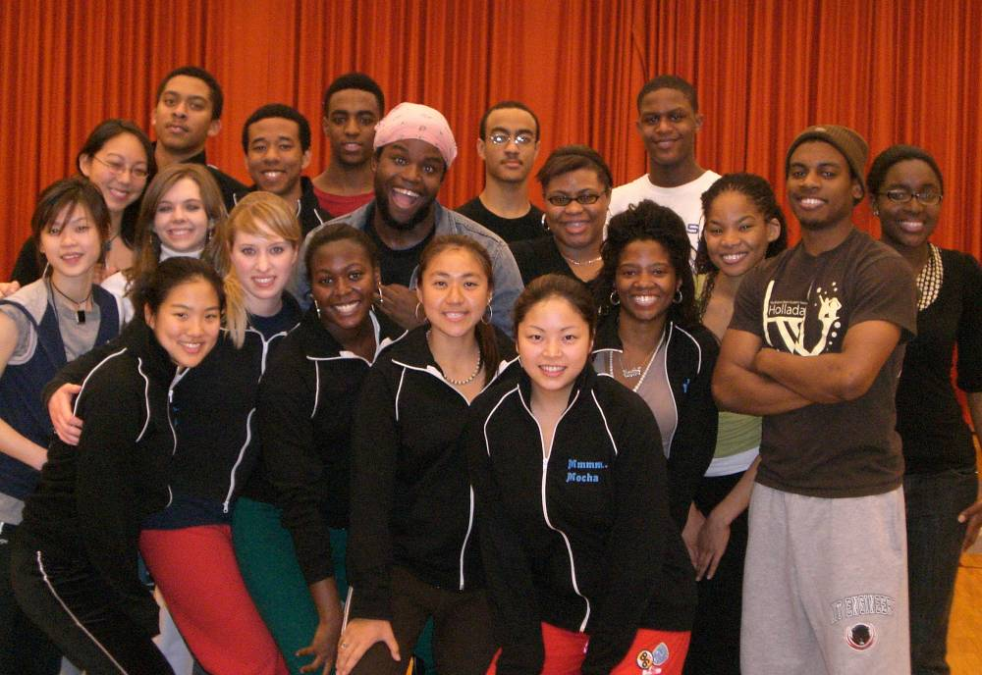

MOCHA

Thanks for coming to…

NIGHTS

Just One Touch
Choreographer: Yamilée Toussaint
Dancers: Nia Beckley, Alex Beyer, Joseph Brown, Adlai Grayson. Corey Harris, Quinnton Harris, Irene Headen, Armand Mignot, Rachel Peterson, Jason Scott, Tamika Tannis, Yamilée Toussaint, Bettina Tso

Sexy Mocha men + Foxy Mocha ladies = an interesting Mocha scenario…

About Us

Mocha Moves was created with the aim to promote and celebrate hip-hop and urban dance culture throughout MIT and the Greater Boston area. Dance is our passion and we love to share this fervor with others. We choreograph our own pieces and our members range from first-time to experienced dancers. We focus mainly on the arts of hip-hop and lyrical, but are open to all forms of dance.

Auditions are held every fall and we encourage anybody with interest in our group to try out and join us in our love for dance!

For more information, please contact the MoCaptains at mocaptains@mit.edu or the entire group at mocha@mit.edu.

MoCaptains:

Nia Beckley ‘08
Irene Headen ‘08
Yamilée Toussaint ‘08

ALEXANDRA BEYER – Be careful with Alex - just like her golden locks, her moves will hypnotize and captivate you.
Mocha
JOE BROWN – His smooth and classic style is straight from the streets of New York. With a splash of Caribbean and beboy moves, he’ll make you forgot about that chicken noodle soup.

DIANA CHENG – Forget high fructose corn syrup, this Mocha newbie is 100% all-naturale!

ADLAI GRAYSON – Caliente, speziato, picante - any way you put it, this well-seasoned dancer is HOT!

IRENE HEADEN - Irene has been with Mocha for three years. Her spellbinding moves will put you in a trance and have you blind for days.

GLORIA LEE – Also known as the AsianGlo, Gloria has the fire you need to make a hot cup of Mocha.

RACHEL PETERSON – Sick of Boston’s cold weather? Have no fear because Rachel brings the heat of the Miami sun with her bright smile and sizzling moves

BETTINA TSO – Don’t let this tiny firecracker fool you…she has the snap, crackle, and pop to ignite any stage!

TAMIKA TANNIS – Straight from NY, she supplies Mocha with gangsta toughness, finesse, and a sassy style.

Amped
Choreographer: Nia Beckley
Dancers: Nia Beckley, Diana Cheng, Ayaboe Edoh, Adlai Grayson, Corey Harris, Quinnton Harris, Tina Lai, Jason Scott, Stephanie Shim, Tamika Tannis

Ever wonder what really goes on when you chug an energy drink? These amped up dancers should have thought twice before they tried to pull that all nighter with the help of that energy drink. Watch as they get hype, smooth, and raw during this Mocha night.

Sweet Dreams
Choreographer: Yamilée Toussaint
Dancers: Alex Beyer, Yamilée Toussaint, Bettina Tso, Anikia Tucker

All women dream of the perfect guy – the one who will love them, flaws and all. However, at times he lies only in our dreams…

Guest Performance: Static Noyze
Dancers: Chung Peng, Enrique Novales, Josh Brand, Kunle Oladehin, Peter Navarro, Yuhei Ogawa

Static Noyze Dance Company combines the experience and ability of its members to develop contemporary and theatrical hip-hop choreography that entertains and inspires audiences. Through the vitality and professionalism of our company we strive to form strong bonds with the community. Contact email: brett.wong@staticnoyze.com

This is for those neo-soul joints. The ones that inspire. The ones that tell stories. The ones that are true to music. The ones that remind of us the past and encourage appreciation for the present. These are the movements and words of mahogany soul.

Midnight Snacks
15 minute Intermission

MOCHA CLASSIC:
Cold Night in the Land of Love
Choreographer: Yamilée Toussaint
Dancers: Nia Beckley, Alex Beyer, Joseph Brown, Corey Harris, Irene Headen, Armand Mignot, Rachel Peterson, Jason Scott, Yamilée Toussaint

It’s a cold night in the land of love. The ice cold temperature freezes lovers one at a time and they are warmed by the touch of their other. They can communicate their feelings for each other while frozen but what happens when temperature heats up? Just watch…

Forbidden Fruit
Choreographer: Nia Beckley, Anikia Tucker
Dancers: Nia Beckley, Anikia Tucker

When the mind and body are torn between reason and desire, the result will have anyone craving, lusting, and itching for that forbidden fruit.

NIA BECKLEY – From both Cali and ATL, she combines her West Coast charm with Southern sophistication.

Stars

AYABOE EDOH – This newbie of Mocha is bringing sexy back with his smooth moves and charming smile.

COREY HARRIS – Hailing from the frigid Upstate New York, Corey will keep you warm with his fiery sense of humor and hot style.

QUINNTON HARRIS – Hailing from Chi-Town, he’s the cutie that all the ladies crave.

TINA LAI – Clear the dance floor, ladies and gentlemen, because she’s the chic with all the moves!

ARMAND MIGNOT – This member of Mocha fulfills 100% of your daily value of fun and entertainment!

JASON SCOTT – This 6’4” wonder will amaze you with more than his height. He’s smooth, sexy, and can shake his money maker!

STEPHANIE SHIM – So you think you can dance? No, but this girl can! Watching her will surely satisfy your appetite for a hot performance.

YAMILÉE TOUSSAINT – This Long Island dance diva brings the illest moves and hypest energy to the Boston area. One taste of this Yama-mama will have you craving more all night long.
ANIKIA TUCKER – This Jamaican princess can do more than the Dutty Wine. Her talent and grace easily fills the stage with a beautiful ambiance.

Mocha Nights:
From Dusk to Dawn…

When the moon rises, a certain group of nocturnal MIT students transform into uncontrollable dance beings – better known as Mocha Moves. Join us in our journey through a mysterious and alluring night, full of the antics and situations faced by the Mocha Stars.

Hosts:
Alia Carter and Uzoma Orji

Get Down!
Choreographers: Nia Beckley, Yamilée Toussaint
Dancers: Nia Beckley, Alex Beyer, Diana Cheng, Adlai Grayson. Corey Harris, Quinnton Harris, Irene Headen, Tina Lai, Gloria Lee, Armand Mignot, Rachel Peterson, Jason Scott, Stephanie Shim, Tamika Tannis, Yamilée Toussaint, Anikia Tucker

The title says it all…

When Darkness Falls
Choreographer: Joseph Brown
Dancers: Nia Beckley, Joseph Brown, Corey Harris, Stephanie Shim, Yamilée Toussaint, Anikia Tucker

What happens in the dark always comes to light. Or does it? Watch the fellas get more than they bargained for in this horrifying hip-hop scenario.

Goin’ Out at 2nite
Choreographer: Adlai Grayson
Dancers: Alex Beyer, Diana Cheng, Ayaboe Edoh, Adlai Grayson, Irene Headen, Gloria Lee, Armand Mignot, Rachel Peterson, Stephanie Shim, Tamika Tannis, Yamilée Toussaint, Bettina Tso

The party is ending at 2 A.M... So whatever you must do... do it now.

One of Those Nights…
Choreographer: Alex Beyer, Jason Scott, Tamika Tannis
Dancers: Diana Cheng, Ayaboe Edoh, Adlai Grayson. Quinnton Harris, Tina Lai, Gloria Lee, Jason Scott, Stephanie Shim, Tamika Tannis, Yamilée Toussaint

When a shaky relationship gets complicated after her man goes out to the club, will she stay, or will she go? Love...lust...pain...apologies...it's about to be one of those nights...

Mahogany Soul
Choreographer: Nia Beckley
Dancers: Nia Beckley, Alex Beyer, Ayaboe Edoh, Quinnton Harris, Irene Headen, Armand Mignot, Rachel Peterson, Jason Scott, Tamika Tannis, Yamilée Toussaint, Bettina Tso, Anikia Tucker

